The human respiratory system is a series of organs responsible for taking in oxygen and expelling carbon dioxide. In terrestrial animals, this is accomplished by breathing. The human body needs oxygen to sustain itself. A complete lack of oxygen is known as anoxia and a decrease in oxygen is known as hypoxia. After four to six minutes brain cells without oxygen brain cells are destroyed and an extended period of hypoxia leads to brain damage and ultimately death
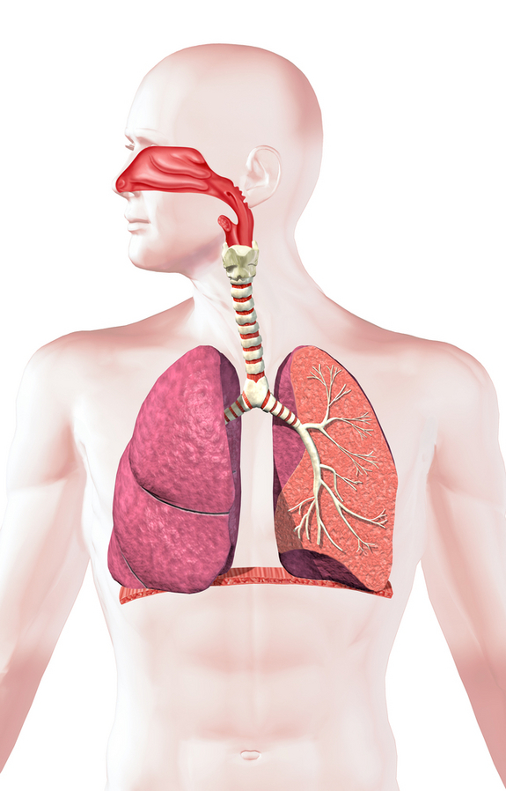
In humans, the average rate of breathing is dependent upon age. Newborns up to 6 weeks take 30 to 60 breaths per minute, while the average resting respiratory rate for adults is 12 to 20 breaths per minute. Physical exertion also has an impact on respiratory rate and healthy adults can average 45 breaths per minute during strenuous exercise.
Description of the respiratory system
The primary organs of the respiratory system are lungs, which function to take in oxygen and expel carbon dioxide as we breathe. Red blood cells collect the oxygen from the lungs and carry it to the parts of the body where it is needed. During the process, the red blood cells collect the carbon dioxide and transport it back to the lungs, where it leaves the body when we exhale.
The exchange of oxygen and carbon dioxide occurs in the alveoli, the tiny sacs that are the basic functional component of the lungs. The alveolar walls are extremely thin (about 0.2 micrometers). These walls are composed of a single layer of epithelial cells and the pulmonary capillaries.
The trachea, also called the windpipe, filters the air that is inhaled. It branches into the bronchi, which are two tubes that carry air into the lungs.
The diaphragm, a dome-shaped muscle at the bottom of the lungs, controls breathing. When a breath it taken, it flattens out and pulls forward, making more space for the lungs. During exhalation, the diaphragm expands and forces air out.
Diseases of the respiratory system
Common diagnostic tools for diagnosing respiratory disease include chest x-ray, pulmonary function test and CT scan. A bronchoscopy is performed by inserting a bronchoscope into the airways — usually through the nose or mouth — to examine for bleeding, tumors, inflammation or other abnormalities.
Diseases and conditions of the respiratory system can be caused by the inhalation of foreign bodies such as cigarette smoke, chemicals, allergens and other irritants. Not all people will develop respiratory ailments as a result of environmental factors, as genetics also play a role in the development of respiratory diseases.
Asthma causes breathing difficulties due to inflammation of bronchi and bronchioles, this causes a restriction in the airflow into the alveoli. Air pollution, tobacco smoke, factory fumes, cleaning solvents, infections, pollens, foods, cold air, exercise, chemicals and medications are some common asthma triggers.
Chronic obstructive pulmonary disease (COPD) is the intersection of three related conditions — chronic bronchitis, chronic asthma, and emphysema. It is a progressive disease that makes in increasingly difficult for sufferers to breath.
Lung cancer is often associated with smoking, but the disease can affect non-smokers as well. Like all cancers, lung cancer is caused by the uncontrolled growth of abnormal cells.
Some other ailments involving the respiratory system are respiratory infections, including tuberculosis, pneumonia and influenza.
Study of the respiratory system
Pulmonologists, a sub-specialty of internal medicine, treat the respiratory system, including the lungs. Because of the critical nature of the respiratory system, pulmonologists work in hospitals as well as in private practice. A pulmonologist must first be certified by the American Board of Internal Medicine and then obtain additional training in the sub-specialty.
Some milestones in the study of the respiratory system include:
- 13th century: Anatomist and physiologist Ibn Al-Nafis advances his theory that the blood must have passed through the pulmonary artery, through the lungs, and back into the heart to be pumped around the body. This is believed by many to be the first scientific description of pulmonary circulation.
- 1897: Gustav Killian uses a rigid esophagoscope to extract a pork bone from a farmer’s bronchus.
- 1898: A. Coolidge performs the first bronchoscopy in the United States at the Massachusetts General Hospital.
- 1905: Looking to improve the care of tuberculosis patients by sharing their experiences and discoveries, a small group of physicians form what becomes the American Thoracic Society.
- 1907: In Philadelphia, Chevalier Jackson develops and improves the instruments for bronchoscopy and esophagoscopy.
- 1963: James Hardy of the University of Mississippi performs the first human lung transplant. The patient lives for 18 days.
- 1964: Shigeto Ikeda develops a prototype of what was to be the first flexible bronchoscope.
- 1983: Joel D. Cooper, a thoracic surgeon, performs the first successful lung transplant in Toronto.
- 1986: Cooper performs the first successful double lung transplant.

