YOU ARE WHAT YOU EAT!

[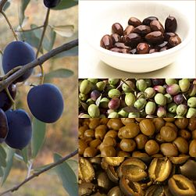](http://es.wikipedia.org/wiki/Archivo:Owoce_Oliwka.jpg)

**ANCIENT GREEK ATE:**

Olives cheese dried fruit fruit **[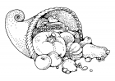](http://www.educima.com/dibujo-para-colorear-cuerno-de-la-abundancia-i17371.html)** **[](http://www.educima.com/dibujo-para-colorear-cuerno-de-la-abundancia-i17371.html)**

bread figs garlic onions

soups salads vegetables

wine honey

There was no sugar,

but they added honey

to sweeten their

dishes.

* Ancient Greeks never ate meat

unless it had been sacrificed to a god first.

* They used their bread to scoop up soups and as a napkin to clean their hands!

**Can you create your own Ancient Greek dish? Add drawings and descriptions.**

**A FOOD PLANNER FOR AN ATHLETE**

**The Ancient Greeks certainly knew the importance of a healthy balanced diet for their prize athletes. They knew that the food we eat is the fuel that makes our bodies work.**

**Create a food planner for an Ancient Greek athlete, making sure you have a balanced daily intake to ensure your athlete is a winner!**

**Make your choices from the selection below:**

|  |  |  |  |  |
| --- | --- | --- | --- | --- |
| aceitera_min.gif  fats | proteinspierna de pollo | carbohydratespan para colorear | cilantro para colorearvitamins  and  minerals | C:\Users\noelia\AppData\Local\Microsoft\Windows\Temporary Internet Files\Content.IE5\NNB6PBPT\MC900199137[1].wmf  Fibre |
| **Olive oil**  **Cheese**  **Nuts**  **milk** | **Seafood chicken**  **Deer**  **Donkey**  **Eggs**  **Cheese**  **Beans**  **Chickpeas**  **lentils** | **Barley**  **Wheat**  **Millet seed**  **Oats** | **Cabbage**  **Carrots**  **Apples**  **olives** | **Beans**  **Chickpeas**  **Lentils**  **Cabbage**  **figs** |

**MEAL PLANNER** dibujos de ensaladas

**BREAKFAST:…………………………………………………………………………………**

**LUNCH:………………………………………………………………………………………….**

**DINNER:…………………………………………………………………………………………**

**SNACKS:……………………………………………………………………………………………**